**Add-Answers**

Key Stage 3: 2003 Paper 1 Level 3-5

1.

2.

3.

4.

Key Stage 3: Paper 1 Level 4-6

5.

1. 1256
2. 4348

6.

7.

Key Stage 3: 2004 Paper 1 Level 3-5

8.

9.

10.

11.

12.

Key Stage 3: 2004 Paper 2 Level 3-5

13.

14.

15.

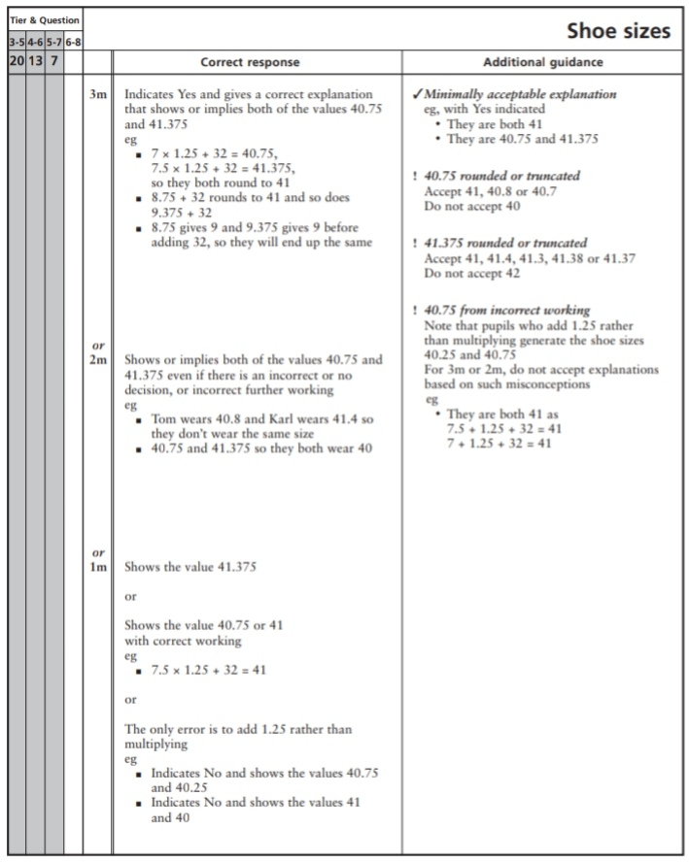

Key Stage 3: 2004 Paper 1 Level 4-6

16.

17.

18.

Key Stage 3: 2004 Paper 2 Level 4-6

19.

20.

21.

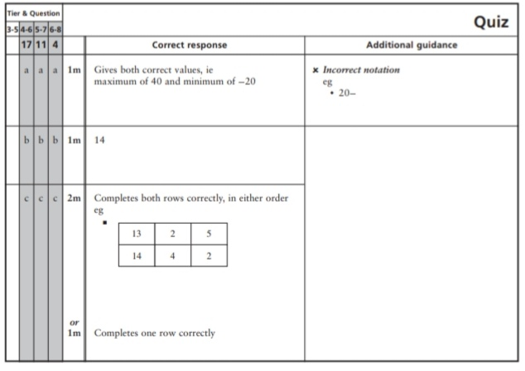

Key Stage 3: 2005 Paper 1 Level 3-5

22.

23.

24.

25.

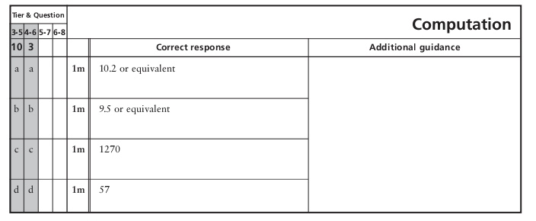

Key Stage 3: 2005 Paper 2 Level 3-5

26.

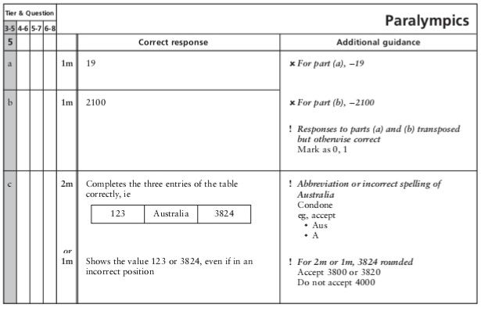

27.

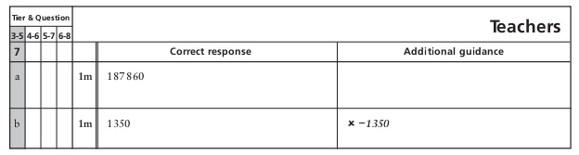

28.

29.

Key Stage 3: 2005 Paper 1 Level 4-6

30.

31.

32.

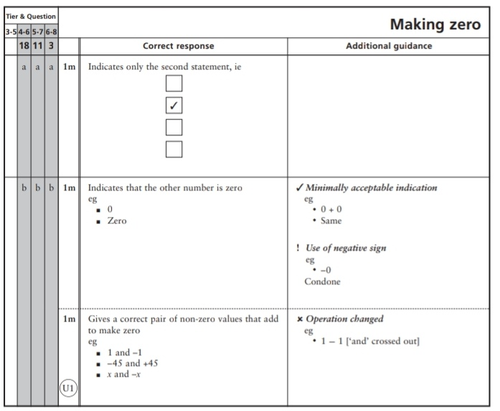

Key Stage 3: 2005 Paper 2 Level 4-6

33.

34.

Key Stage 3: 2006 Paper 1 Level 3-5

35.

36.

37.

Key Stage 3: 2006 Paper 2 Level 3-5

38.

39.

40.

Key Stage 3: 2006 Paper 1 Level 4-6

41.

Key Stage 3: 2006 Paper 2 Level 4-6

42.

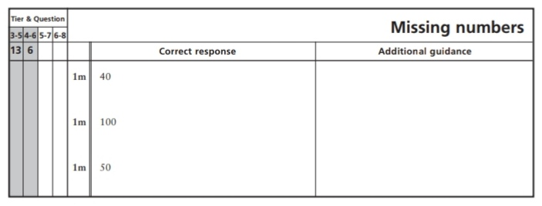

Key Stage 3: 2007 Paper 1 Level 3-5

43.

44.

45.

46.

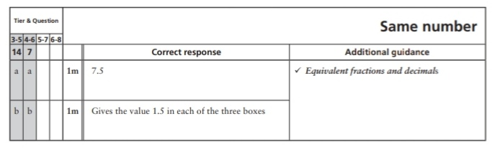

Key Stage 3: 2007 Paper 2 Level 3-5

47.

48.

49.

Key Stage 3: 2007 Paper 1 Level 4-6

50.

51.

Key Stage 3: 2007 Paper 2 Level 4-6

52.

53.

Key Stage 3: 2008 Paper 1 Level 3-5

54.

55.

56.

57.

Key Stage 3: 2008 Paper 2 Level 3-5

58.

59.

Key Stage 3: 2008 Paper 1 Level 4-6

60.

61.

62.

Key Stage 3: 2008 Paper 2 Level 4-6

63.

Key Stage 3: 2009 Paper 1 Level 3-5

64.

65.

66.

67.

68.

69.

70.

Key Stage 3: 2009 Paper 2 Level 3-5

71.

72.

73.

Key Stage 3: 2009 Paper 1 Level 4-6

74.

75.

76.

77.

78.

Key Stage 3: 2009 Paper 2 Level 4-6

79.

80.

Key Stage 3: 2010 Paper 1 Level 3-5

81.

82.

83.

84.

85.

86.

87.

88.

Key Stage 3: 2010 Paper 2 Level 3-5

89.

90.

91.

Key Stage 3: 2010 Paper 1 Level 4-6

92.

93.

Key Stage 3: 2010 Paper 2 Level 4-6

94.

95.

96.

Key Stage 3: 2011 Paper 1 Level 4-6

97.

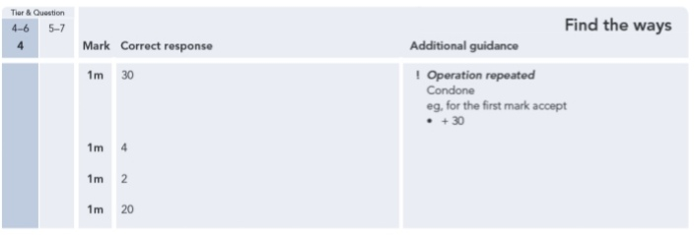

Key Stage 3: 2011 Paper 2 Level 4-6

98.

99.

100.

101.

102.

